Pokhara University

Level: Bachelor | Semester – Spring | Year : 2008
Programme: BE |  | Full Marks: 100
Course: Network Theory |  | Time : 3hrs.

Candidates are required to give their answers in their own words as far as practicable.
The figures in the margin indicate full marks.

Attempt all the questions.

 | - Determine the solution of the current differential equation, I" (t) + 3i' (t) + 2i (t) = 4e^{t}, initial conditions I (0+) = 1, i' (0+) = - 1. Use classical method.  - Determine the current response of the network shown in fig. below when the switch S is closed, using Classical approach. Assume that both inductor and capacitor have zero initial energy. | 7  8
 | - Determine the currents in the loop of the network shown, assuming zero initial conditions. Use laplace transform method.  5  1H  1H  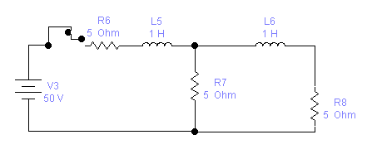  50V  5∩  5 ohm  - The response i(t) in an electrical circuit is described by the differential equations given. Use Laplace transform method to obtain the response i(t).  d²i/dt² + 2di/dt + 5i = 4e^{-t}.; i(0) = 3 and di/dt (0) = - 3 | 8  7
 | - What is the transfer function of the network? For the network given below, obtain the voltage transfer function V₂(s)/V₁(s).  - Apply Routh criterion for the following denominator polynomials and verify the Stability of the network.  s⁴ + 2s³ + 7s² + 10s + 10 = 0 | 8  7
 | - Determine the Fourier Transform of the function shown below.  Vo  0  -T  t  -Vo | 7
 | - Sketch the bode plot for the transfer function G (s) = 75 (1+0.2S) / S (S²+16S+100). | 8
 | - Write three necessary and sufficient conditions of PRF. Check given function is PRF or not: (s+2)(s+4)/(s+1)(s+3)  - Synthesis the foster-II and caur-I forms of RC driving point function, Z_{RC} = 2(S+2)(S+4)/(S+1)(S+3) | 7  8
 | - Find the equivalent T network for the given ∏ network.  - Find the y and z parameters for the circuit shown in Fig. below. | 7  8
 | Write short notes on (Any Two)  - Ideal and non-ideal case of Band pass and Band Stop Filters.  - Step response of R-C series circuit  - Damping factors, Q factors | 2×5

